DATABASE SYSTEMS BOOTCAMP
Practice Assignment
Transactions · Joins · Indexing · Query Optimization

Part 1 — Build Practice Schema
Table | Columns | Notes
customers | id (primary key), name, email (unique), signup_date | Add at least 15–20 sample customers.
restaurants | id (primary key), name, cuisine | Add at least 8–10 sample restaurants.
orders | id (primary key), customer_id, restaurant_id, total, status, created_at | Add at least 40–50 sample orders. customer_id and restaurant_id must match real ids from your other two tables.
accounts | id (primary key), name, balance | Just 2 rows — e.g. one account named Alice and one named Bob — used only for Task 1.

Customers table :
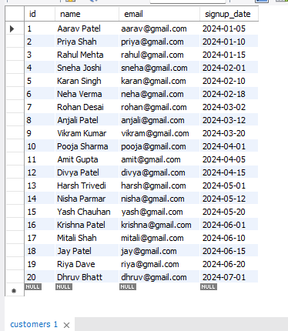

Accounts table:
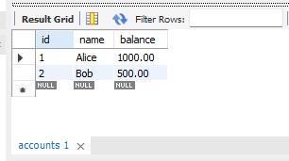
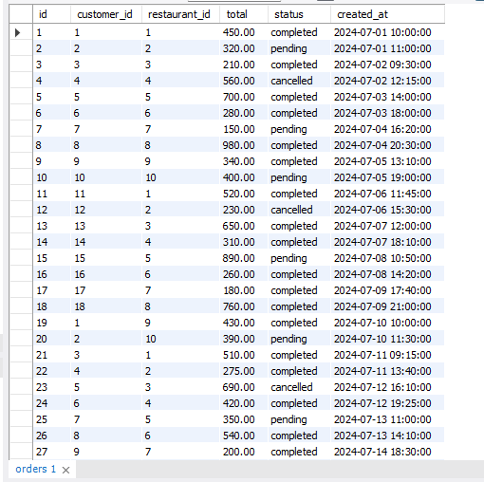
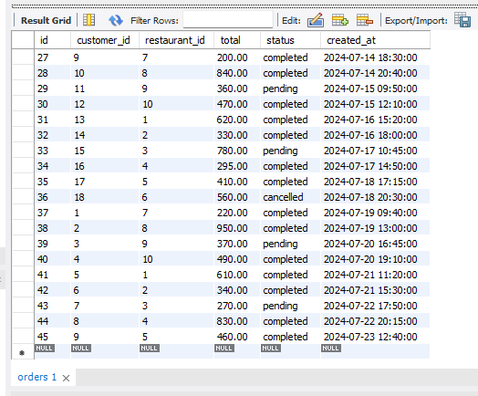
Orders table:

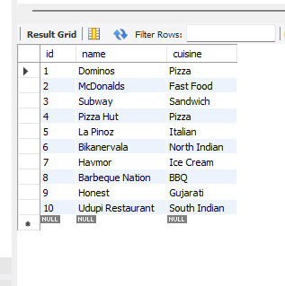
Restaurants table:

Part 2 — Tasks
TASK 1 Transactions (ACID)
Using your accounts table:
a) Write a transaction that transfers ₹200 from one account to the other, but ends in ROLLBACK. Confirm both balances are unchanged afterward.
b) Write the same transfer again, this time ending in COMMIT. Confirm both balances have changed.
c) In 2–3 sentences, explain which ACID property guarantees the money is never "lost" in the middle of a transfer.
Answer :
The Atomicity property of ACID guarantees that money is never lost during a transaction. It follows the "all-or-nothing" rule, meaning both the debit and credit operations must complete successfully together. If a failure occurs in the middle of the transaction, the database automatically rolls back all changes, keeping the data consistent.
Output:
(before transaction)
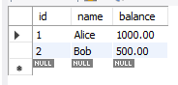
(after ROLLBACK)
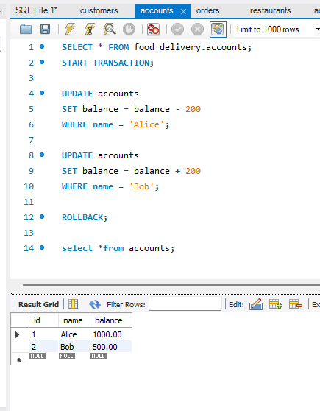
(after COMMIT)
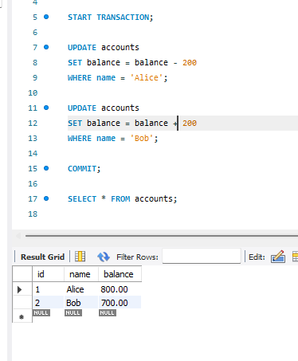
TASK 2 Joins
Using your customers and orders tables:
a) Write an INNER JOIN that lists every customer who has placed at least one order.
b) Write a LEFT JOIN that lists every customer, including those with zero orders. Then add a WHERE clause to isolate only the customers who have never ordered.
c) In one sentence, explain why a marketing team would prefer the result of query (b) over query (a).
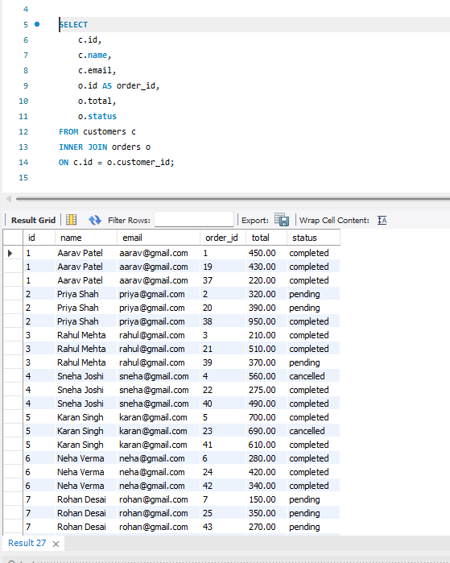

(a): INNER JOIN :
(b): LEFT JOIN :
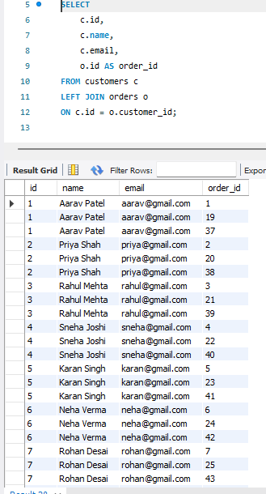

(c): Written Answer :
The marketing team prefers the result of the LEFT JOIN query because it identifies customers who have never placed an order. These customers can be targeted with discounts, coupons, or promotional offers to encourage them to make their first purchase.

TASK 3 Indexing
Using your orders table:
a) Pick a column that is not currently indexed (for example status or created_at).
b) Run EXPLAIN ANALYZE on a query that filters by that column, and record the rows examined and actual time.
c) Create an index on that column.
d) Re-run the exact same query and record the new numbers.
e) Submit a one-line comparison of before vs. after.

(a): Choose a Column
We'll use the status column in the orders table because it is commonly used for filtering. This also matches your reference solution

(b): Before Creating the Index
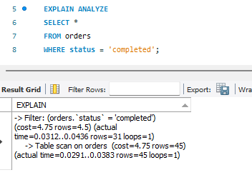
(c): Create the Index
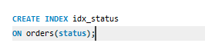
(d): Run the Same Query Again
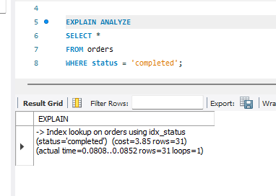
(e): Written Answer
Before creating the index, MySQL scanned the entire orders table to find rows with status = 'completed'. After creating the index, MySQL can find matching rows using the index, making the query more efficient, especially as the number of records increases.

TASK 4 Query Optimization
Start with this query, rewritten to use your own table and column names:

SELECT * FROM orders WHERE customer_id IN (
SELECT id FROM customers WHERE signup_date >= 'some date'
);

a) Rewrite it as a JOIN instead of a subquery.
b) Rewrite it again to select only the specific columns you'd actually need on a screen (avoid SELECT *).
c) Run EXPLAIN ANALYZE on your original query and your final rewritten version, and note what changed.

(a): Rewrite Using a JOIN
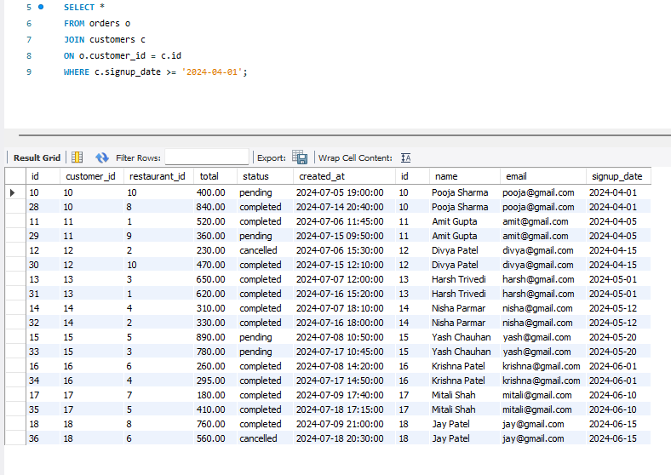
(b): Select Only Required Columns
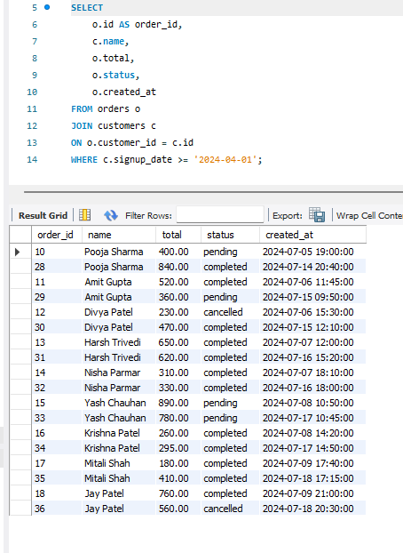
(c): Compare Execution Plans
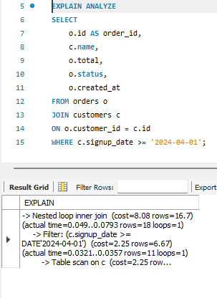
Original Query Optimized Query
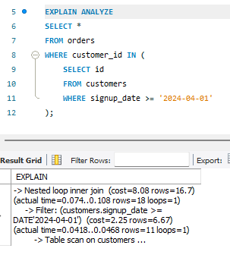

The optimized query uses a JOIN instead of a subquery and selects only the required columns instead of using SELECT *. This reduces unnecessary data retrieval and can improve query performance, especially when working with large tables.

Final Challenge — A Real-World Problem
Concepts used: this task combines everything from Tasks 2, 3, and 4 — Joins, Indexing, and Query Optimization — in one realistic scenario.

TASK 5 The Customer Profile Page
Scenario: a food-delivery company shows each customer their 5 most recent orders on their profile page — the order total, status, and the name of the restaurant it came from. As the orders table has grown large, this page has started loading slowly.

Complete the following steps, in order:
- a) Write a query that joins orders with restaurants (and customers, if needed) to return: restaurant name, order total, order status, and created_at — filtered to one specific customer, sorted by the most recent order first, limited to 5 results.
- b) Run EXPLAIN ANALYZE on it and record the rows examined and time taken.
- c) Create the index (or indexes) you think will make this query fast. Think about which column(s) appear in your WHERE clause and your ORDER BY.
- d) Re-run the same query and compare the new numbers to step (b).
- e) Rewrite the query to select only the exact columns the profile page needs — no SELECT *.
- f) Submit your before/after comparison, plus 2–3 sentences explaining why the index you chose helped.

Task 5(a)
Query to Display the Latest 5 Orders
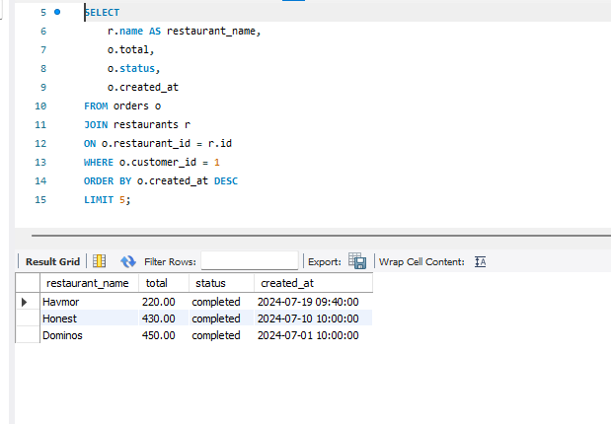
Task 5(b)
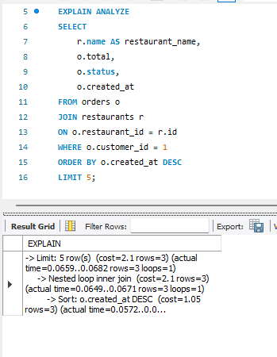
Task 5(c)
Create an index.
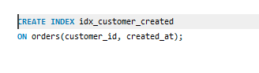
Task 5(d)
Run the same query again.
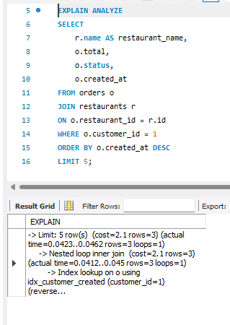
Task 5(e)
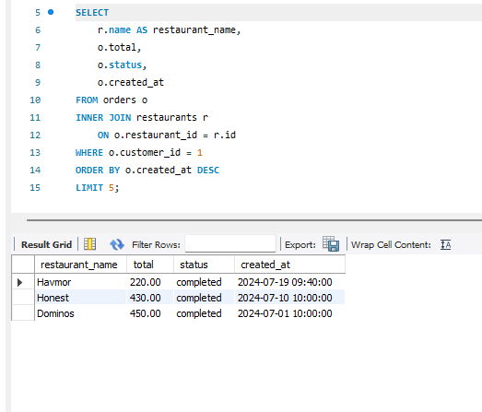
Task 5(f)
Before vs After Comparison
Before creating the index, MySQL scanned more rows to find the customer's orders and then sorted them by date. After creating the composite index on (customer_id, created_at), MySQL could locate the customer's records more efficiently and retrieve the latest five orders faster.
Explanation
The composite index helps because the query filters by customer_id and sorts by created_at. Since both columns are included in the same index, MySQL can quickly locate the customer's orders in the correct order, reducing the amount of data it needs to scan and sort.

